ELMT platform Installation and Configuration

Version-1

|  |  |
| --- | --- |
| **Prepared By:** | Dhivya Shanmugaraj |
| **Technical Lead/Manager:** | Dhivya Shanmugaraj |
| **Dated:** | 21st January 2019 |
| **Review BY:** |  |
| **Review Date:** |  |

|  |  |
| --- | --- |
| **Abbreviation** | Description |
| **ELMT** | **E**nterprise **L**andscape **M**anagement and **T**ransformation |

1. **Installation Tools:**

Platform (ELMT) is installed using the following tools:

* **IDE-Eclipse Oxygen 2**
* **Programming- Java version 8**
* **Application Server- Jboss 4.2.2**
* **Database – SQL server 2012**

1. **Configuration:**

The following are the steps to configure and run the ELMT platform in Eclipse IDE.

**Step 1:**

Go to Eclipse installed folder and open eclipse.

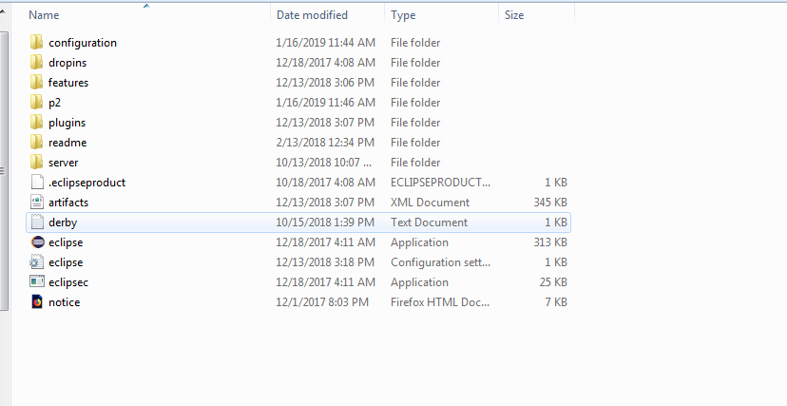

**Step 2:**

Now, browse for the workspace instance which you have created for configuration. For example. Create a new folder (which is the workspace) in your preferred drive and copy and paste or browse the workspace.

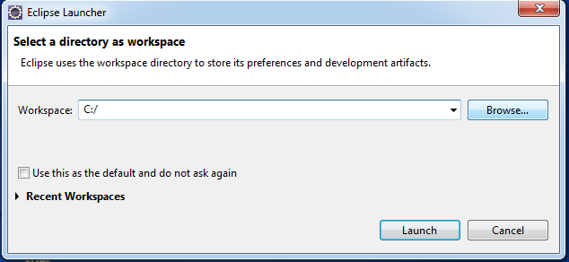

**Step 3:**

Then the corresponding workspace will be opening.



**Step 4:**

Below is the current workspace in the eclipse. It is empty as no project has been configured yet.

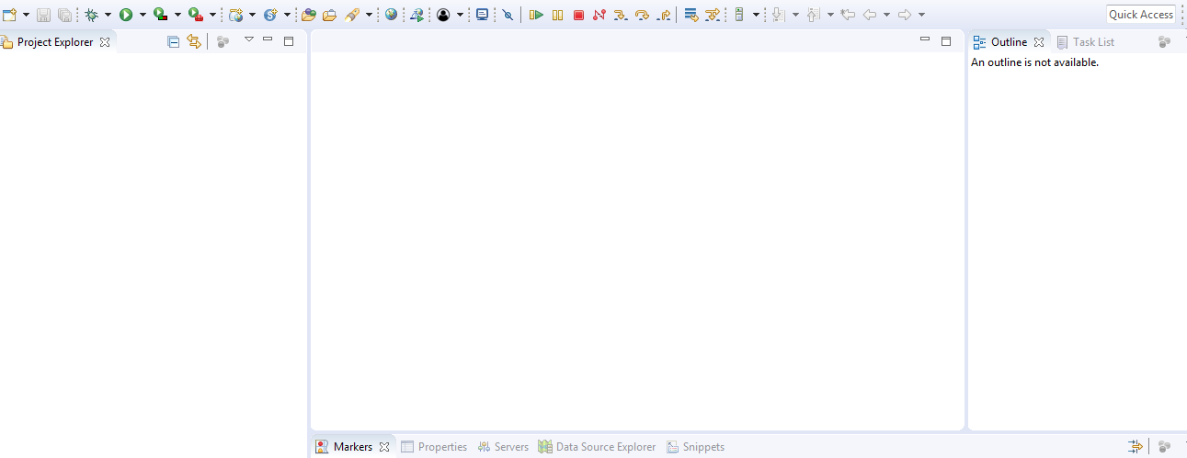

**Step 5:**

Now import the existing source from the desktop into the newly created workspace as File->Import

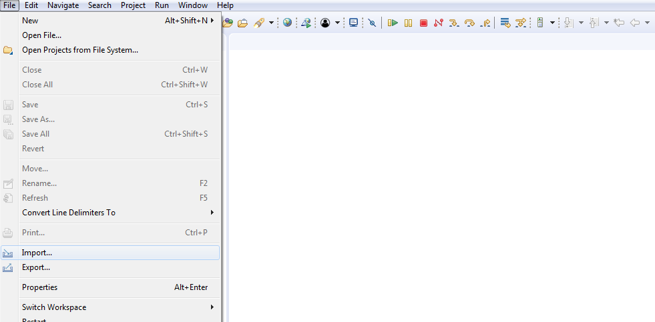

**Step 6:**

Select the “Existing Projects into Workspace” option and click next.

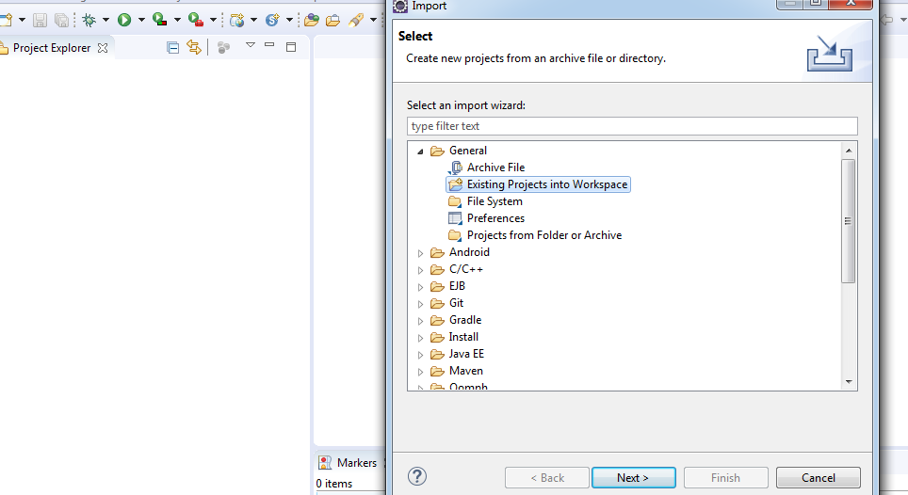

**Step 7:**

Then browse for the existing source and check the option “Copy Projects into workspace” and click Finish.

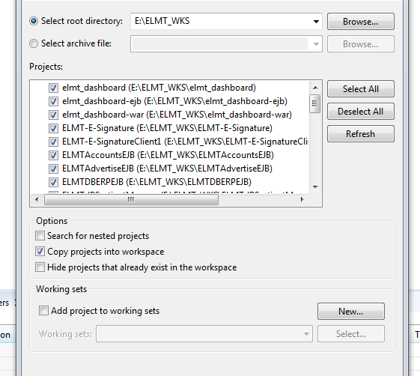

**Step 8:**

Now the ELMT project is imported as shown below

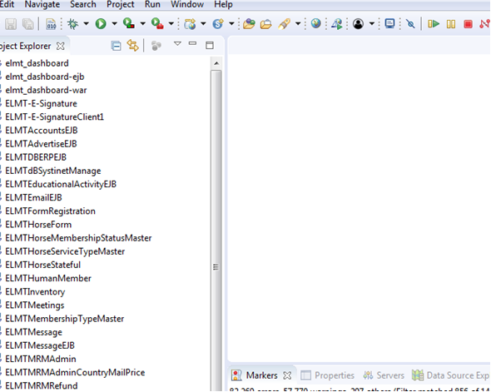

**Step 9:**

Now configure the libraries to the project. Right click the elmt_dashboard-war->select properties

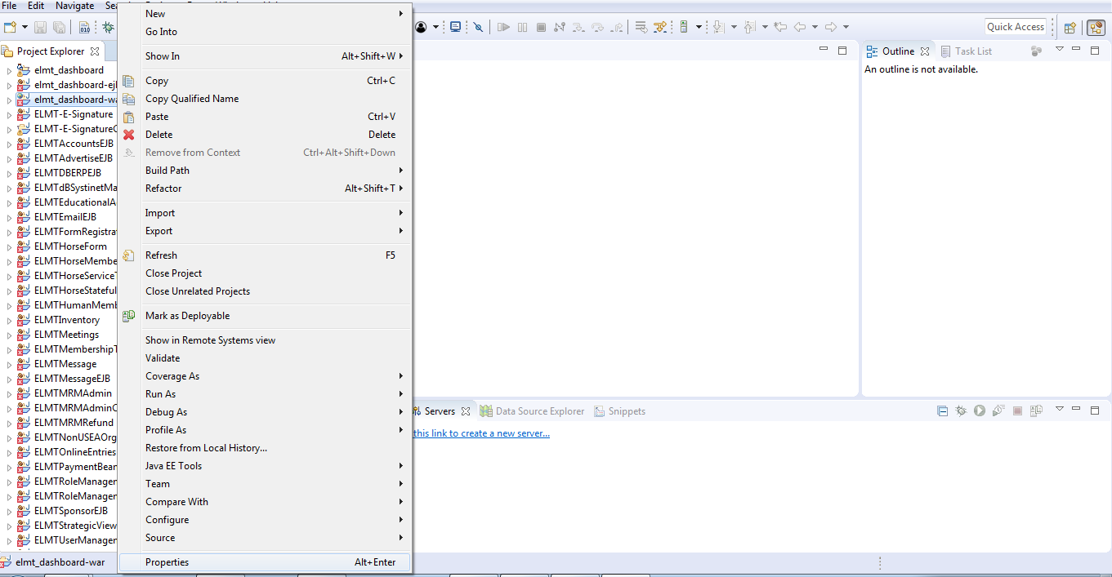

**Step 10:**

Click Add external jar and browse to the installed jars and add those and click finish button.

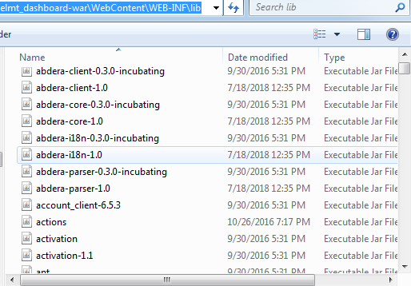

**Step 11:**

Next, add the new server into workspace and configure it to the project. Click servers tab.

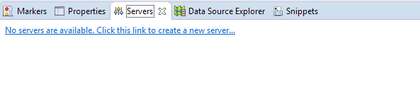

**Step 12:**

Select Jboss AS 4.2 with the default values and click Next button.

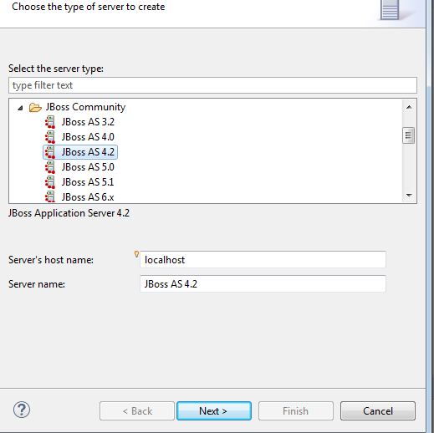

**Step 13:**

Let be with default values and click Next.

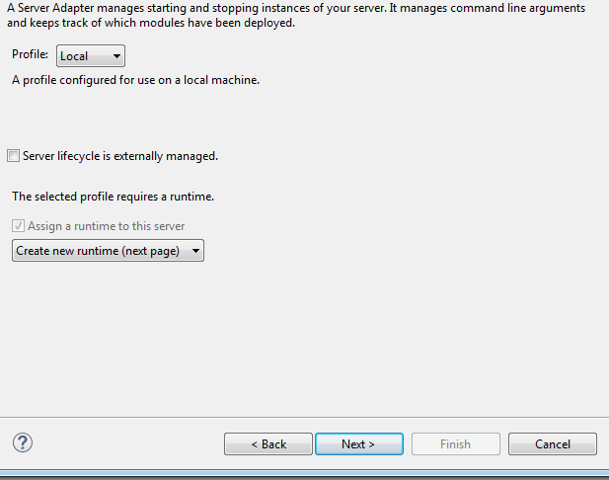

**Step 14:**

Now browse for the Jboss installed path and configure the Java version to 1.8. Then click Finish. Server is successfully added.

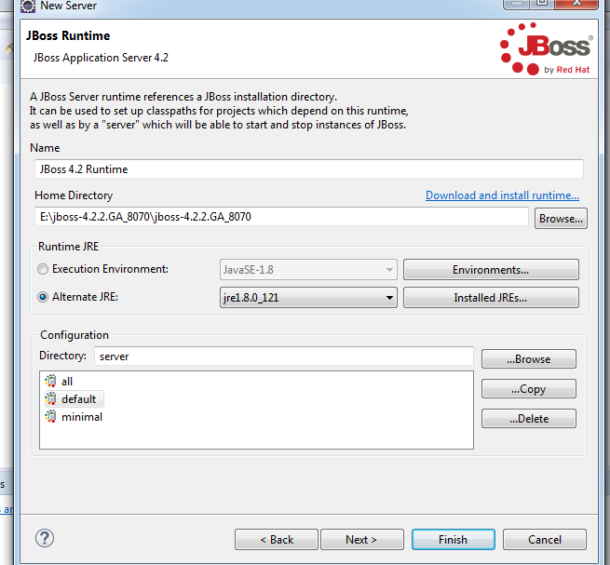

**Step 15:**

Now increase the Start time in the Timeouts tab to 5000 seconds and change the web port to Jboss’s port.

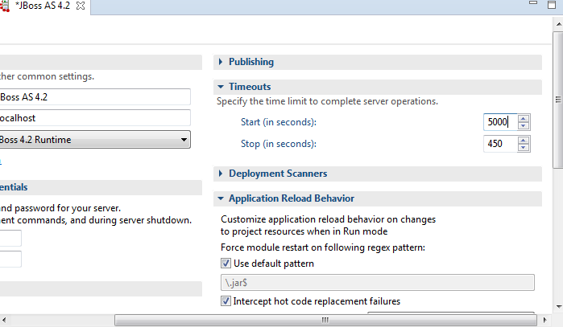

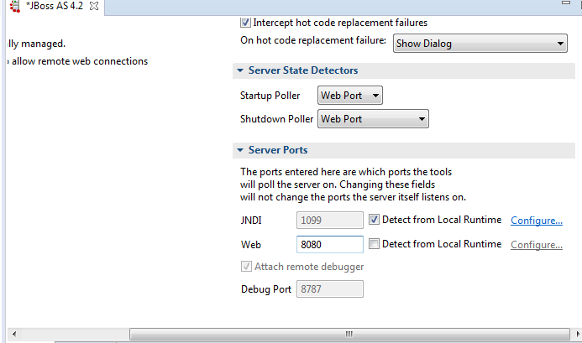

**Step 16:**

Below is the screen depicts the adding of project to the created Jboss server instance. Right click the newly created Jboss server->select Add and Remove

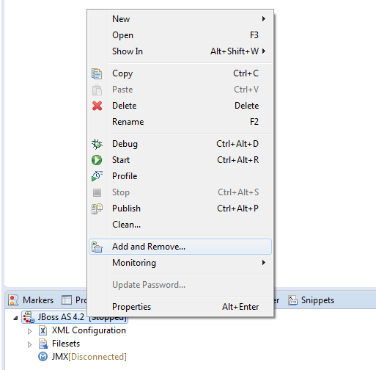

**Step 17:**

Configure the available project to the server by clicking the Add button and then click Finish button.

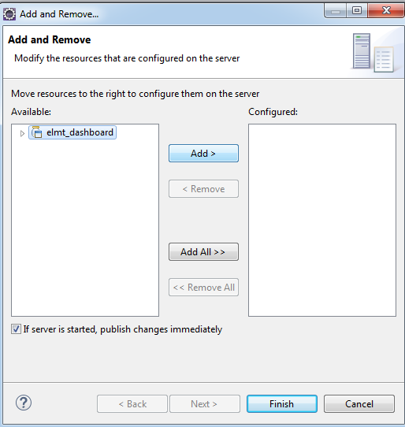

**Step 18:**

Go to Servers tab where you can see the configured project under Jboss server instance. Once the server is started by clicking the Start button, project is deployed and loaded.

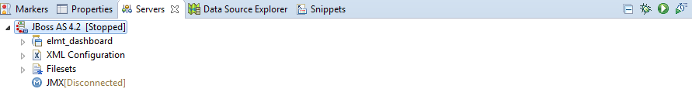

**Step 19:**

Next to build the project, go to Project tab and select Clean.

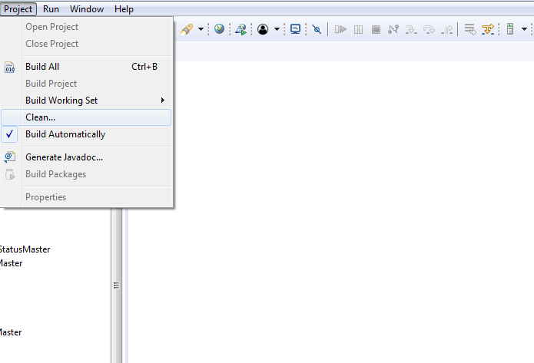

**Step 20:**

Then check the projects which need to be clean and build and then click Clean.

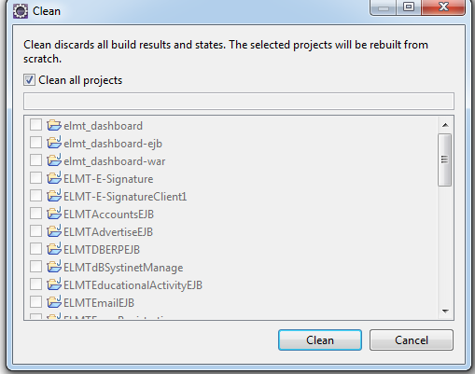

**Step 21:**

Go to Jboss-web.xml to change the context root to access the project. Once the server is started, the project is accessed using the following URL.

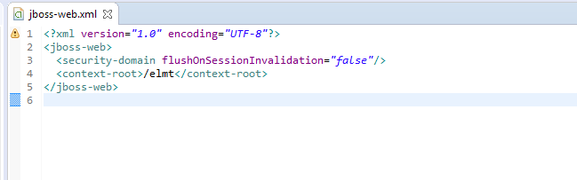

**Step 22:**

Go to Jboss installed folder, Jboss4.2.2/server/default/deploy/add the respective following ds file.



**Step 23:**

Edit the ds file accordingly to map with the database connection.

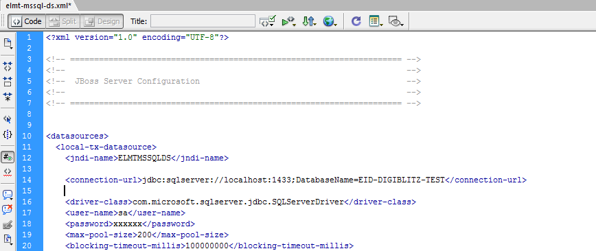

**Step 24:**

Once the server is started, the project is accessed using the following URL.

<http://localhost:8080/elmt>

